Project report

Pengcheng Liu 49791816

Mike Mika 36764576

UML diagram is too big to fit into the page, please see the Seng201.pdf file for the original UML diagram.

Collections have been made into setters and getters, we created private int, String and Boolean type items in the GameManager class to collect all the data from GUI input, and setters and getters are used to set the value of the items and access the items.

**Unit Testing**

We have cover about 6.3 percent of testing’s of our functions but we could not test the Application window builder of setters and getters, we had some difficult time on testing this part of the system. And also had some time in testing random events

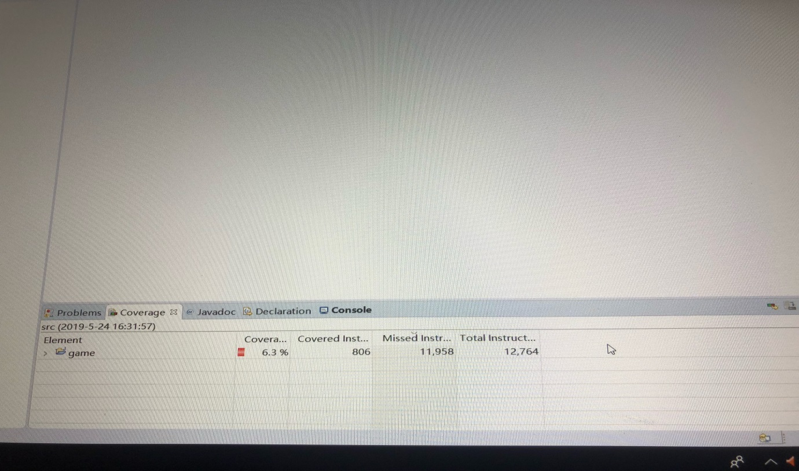

Thoughts and feedbacks (Pengcheng Liu):

The project is quite straight forward with all the help we can get with tutors and tutorials from quiz server.

What went well: First we start with the UML diagram and started some classes before the term break. We’ve design the UML with a few inheritance and multiple classes. Each class connects well and have no problem.

What didn’t go well: After the term break we both have our own stuff to do, so we didn’t start again till the third week back. Although each class connects with each other with no problem, I’ve encountered a lot problem with using multiple classes in the application windows and I couldn’t figure it out, so I had to put all other classes like crew, shop and inventory into the GameManager class.

What could improve: For the game we designed, we could definitely add more pictures and more characters. We could start earlier next time. Have multiple classes, since I’ve figured it out but due to the due date, I have not time to bring back the other classes.

Effort spent: I think for myself I spent around 40 hours towards this project.

Thoughts and feedbacks(Mike Mika):

The project was a learning curve for me, it was vital to create a UML diagram in order to design the game better,

Good things: we started off simple and come to an understanding about UML, we agreed a lot on what to put in the UML and what needs to be changed, there were no problems with that.

It was good to discuss in our diagram whether it was better to put in interface for our diagram or not so we leave it out and put in some Classes and subclasses that goes with the inheritance. It was good that we meet before the break started early and we had a fair idea of what our design should look like. It was good to start early.

It was good to work my partner as to develop our skills of communicating with one another.

Bad things:

We were not able to meet again but we eventually did and got back into it. It was a fast process with my partner and it was all good in the end.

I would agree with my partner that we might need to put in picture and features that would attract player to play the game, if we had more time it would be done even better.

I might have spent over 30hrs.

**We agree we’ve both get 50% of the contribution towards this project.**